**Git HOL – 1**

**Steps -**

**Step 1: Setup your machine with Git Configuration**

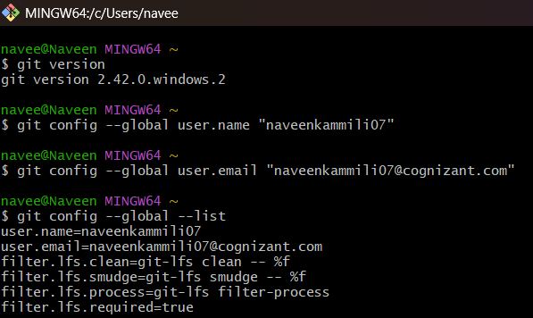

**Step 2: Integrate notepad++.exe to Git and make it a default editor**

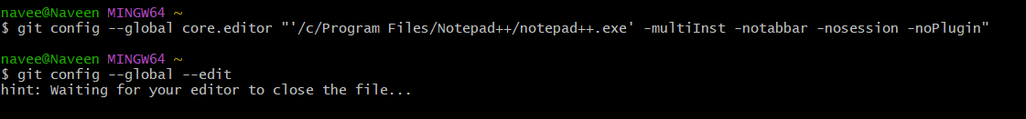

**In Notepad++ -**

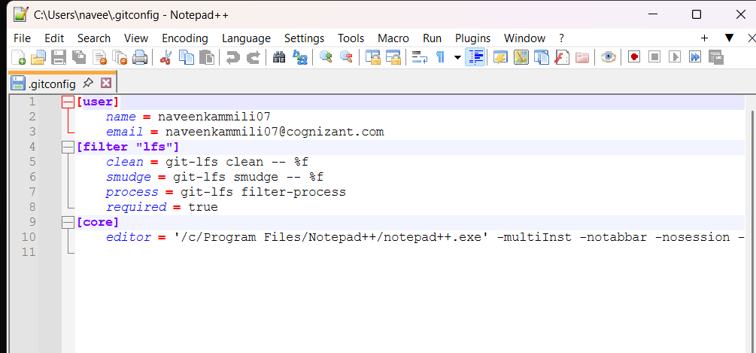

**Step 3: Add a file to source code repository**

